**How to do Financial Analysis of a Company in Excel - Full Tutorial for Beginners from Scratch**

<https://www.youtube.com/watch?v=8NelYFn07jg&list=WL&index=5&t=13s>

Capital in business refers to the sum of financial assets required to produce goods or services. These funds can be used to initiate operations, meet daily expenses or grow and expand the business.

The different types of capital include:

1. Financial: Debt, Investment, Equity, Working Capital
2. Human: Social, Skills/Talent, Intellectual
3. Natural: Commodities, Animals, Vegetation, Ecologies

Finance Capital:

Debt: Debt is a loan or financial obligation that must be repaid in the future. It has an interest expense attached to it, which is the cost of borrowing money. The money received as debt is used to purchase an asset and fund the operation of a business, which in return generates revenues for a company.

Equity: Equity is ownership in a company, and equity investors will receive a part of the company if it is sold or lose some part if the company experiences loss. Unlike debt, it does not have to be repaid and has no interest expense. Equity is used to fund the business and purchase assets to generate revenue.

Human Capital:

Intellectuals refer to people's intelligence, which can be used to run the company successfully, think creatively, solve problems, form strategies, etc.

Skills and Talents help a company to implement the business operation and generate revenues. It includes manual labor, physical exertion, social influence, etc.

Natural Capital:

Businesses can also use natural capital to generate income and increase production. Many businesses use natural resources such as water, wind, solar, animals, trees, plants, and crops to operate their company and increase value over time.

Tangible Assets: Tangible Assets are assets with a physical form that holds value. It includes property, plant, and equipment.

1. Fixed Assets: Fixed or hard assets are those held by a business for a long time and cannot be easily converted into cash. Fixed tangible assets are depreciated over a while.
2. Current assets or liquid assets are those assets that can easily be converted into cash and are in the business for a short period, generally less than or equal to one year.

The liquidity of current assets is significantly greater than that of fixed assets.

Sales: A sale is a transaction between two or more parties exchanging goods or services for money or other assets. In the financial markets, a sale is an agreement between a buyer and seller involving the price of a security and its delivery for agreed-upon compensation.

Profit: Profit is the money you have left after paying for business expenses. There are three main types of profit: gross profit, operating, and net profit. Gross profit is the biggest. It shows what money was left after paying for the goods and services sold.

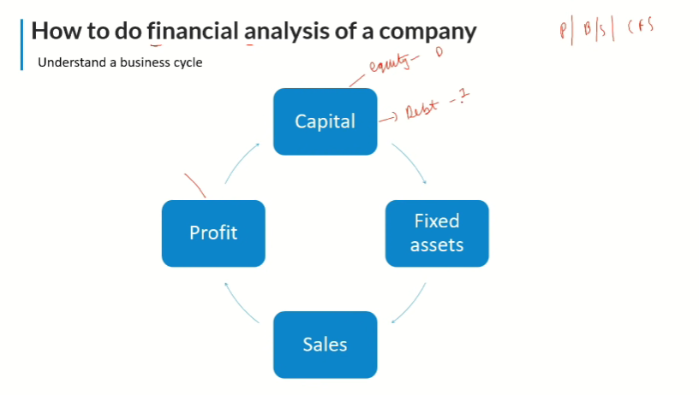

**Liability:** is a term in accounting used to describe any financial obligation a business has to pay at the end of an accounting period a person or a business. Liabilities are settled by transferring economic benefits such as money, goods, or services.

**Current Liabilities(Short-Term liabilities):** These refer to those financial obligations which a company is liable to settle or pay off within 12 months. They are essential to a company’s workday functions as current liabilities directly affect its working capital and liquidity.

Examples of current liabilities are – bills payables, trade payable, creditors, bank overdrafts, outstanding or accrued expenses, short-term loans or debentures, etc.

**Non-current liabilities(Long-Term liabilities**): These are financial obligations that a company is not liable to pay off or settle in the short run of its business operations, i.e., 12 months.

Examples of non-current liabilities are – debentures, mortgage loans, deferred tax payable, bonds, derivative liabilities, etc.

**Contingent liabilities:** Those obligations that might or might not arise in the future. In the accounting context, contingent liabilities are only recorded in the books if they are at least 50% likely to occur in the future. Examples are Warranty Liability, Lawsuits payable, Investigations, etc.

**Liquidity:** In financial markets, liquidity refers to how quickly an investment can be sold without negatively impacting its price. The more liquid an investment is, the more quickly it can be sold (and vice versa), and the easier it is to sell it for fair value or current market value.

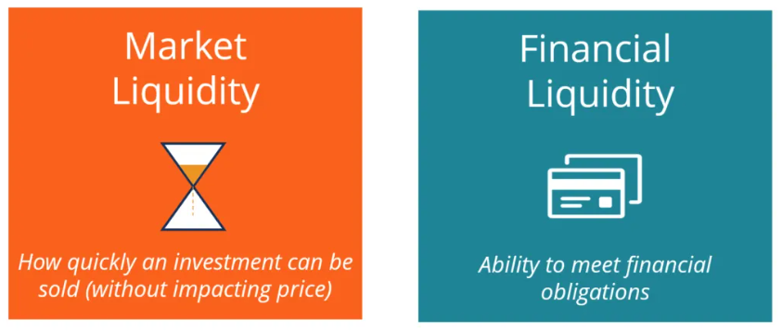

**Working Capital:**

Formula: Working Capital = Current Assets – Current Liabilities

The working capital formula tells us the short-term liquid assets available after short-term liabilities have been paid off. It measures a company’s short-term liquidity and is important for performing financial analysis, financial modeling, and managing cash flow.

**Financial Liquidity:** Items on a company’s balance sheet are typically listed from the most to the least liquid. Therefore, cash is always listed at the top of the asset section, while other assets, such as Property, Plant & Equipment (PP&E), are listed last.

Current Ratio – Current assets minus current liabilities

Quick Ratio – The ratio of only the most liquid assets (cash, accounts receivable, etc.) compared to current liabilities

Cash Ratio – Cash on hand relative to current liabilities

**Stocks Analysis | Company Analysis**

Links:

<https://www.investopedia.com/articles/fundamental-analysis/09/five-must-have-metrics-value-investors.asp>

<https://www.fool.com/investing/2018/03/21/9-essential-metrics-all-smart-investors-should-kno.aspx>

1. CAGR (Compounded Annual Growth Rate)

<https://www.investopedia.com/terms/c/cagr.asp#toc-what-is-an-example-of-compound-annual-growth-rate-cagr>

<https://www.lawinsider.com/dictionary/ebitda-cagr>

<https://www.investopedia.com/terms/r/revenue.asp>

* 1. Top Line/Sales CAGR
  2. Bottom Line/Profit CAGR
  3. EBITDA CAGR

The term "EBITDA CAGR" is a measure of the compound annual growth rate in earnings before interest, taxes, depreciation, and amortization. It underscores a company’s current operating profitability.

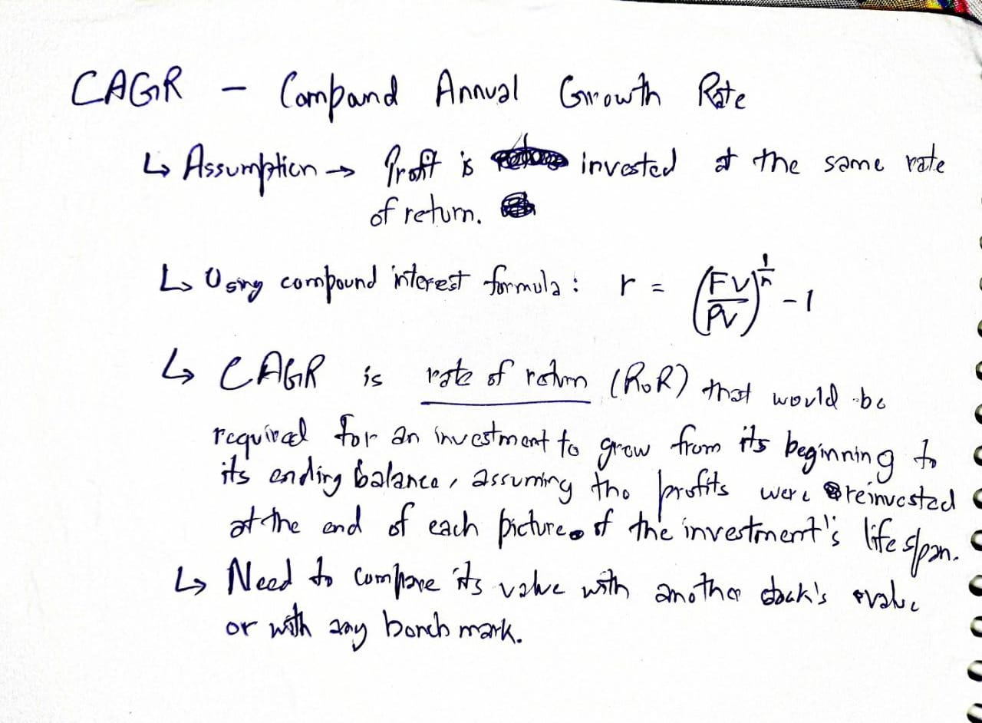

1. Ratio Analysis
   1. Debt to Equity Ratio:

- If the debt is higher than Equity, then it can be a problem when revenue falls

<https://www.investopedia.com/terms/d/debtequityratio.asp>

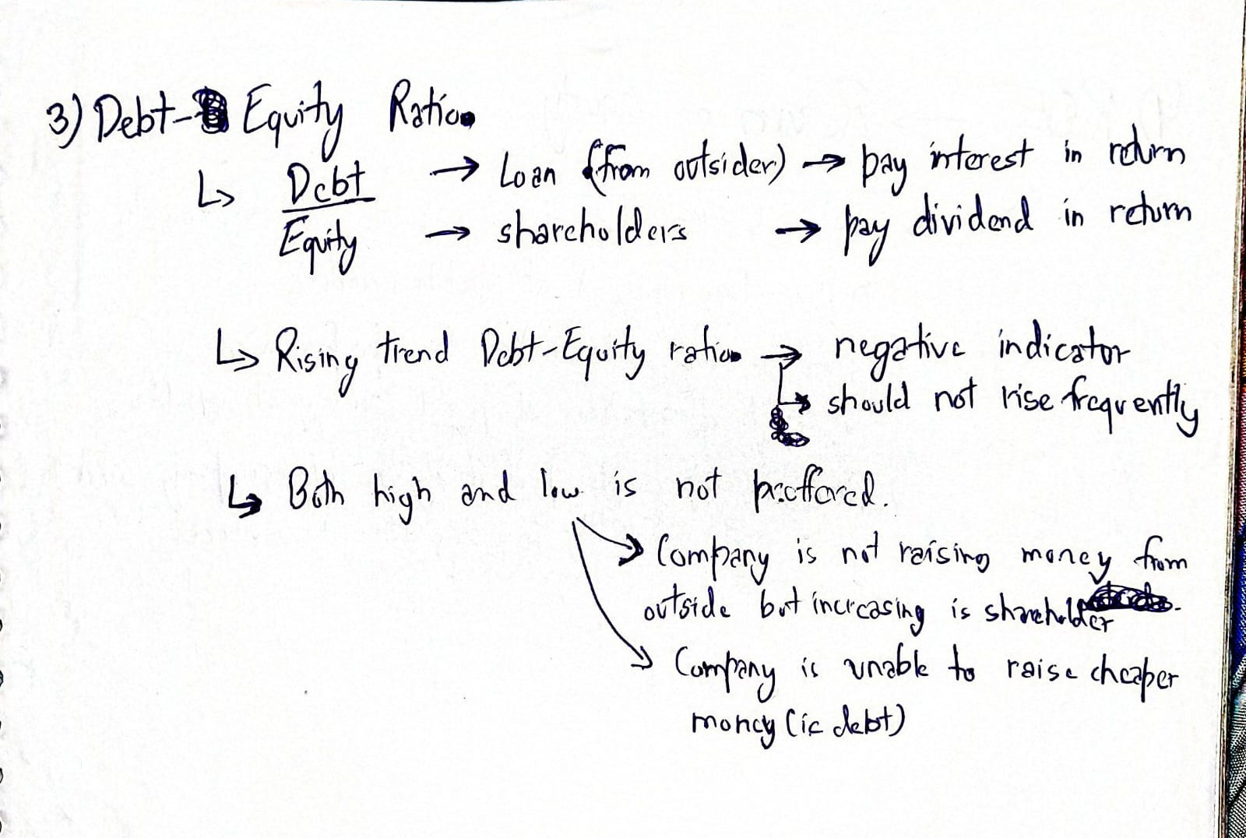

* 1. PE Ratio (Price to Earning Ratio):

- It tells how cheap or costly the stock price is. The higher the PE, the higher the stock price, and vice-verse.

- I have to compare one stock PE with another stock PE ratio or one stock price with another.

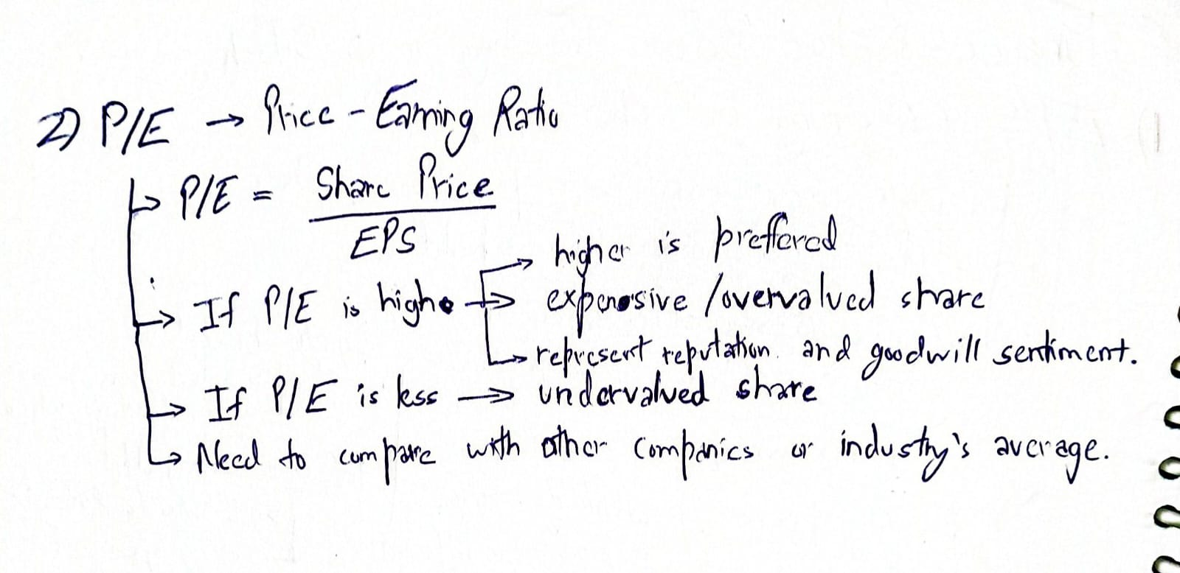

* 1. ROE (Return on Equity):

- Amount of return one is getting on equity invested in the business.

- Return mean PAT(Preference After Tax)

- Higher ROE is better

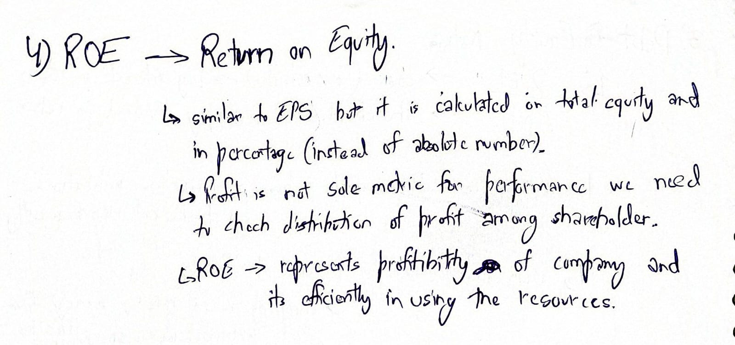

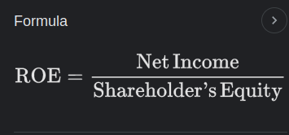

Shareholder’s Equity: Total Shareholder’s Fund

1. Cash Flow:
   1. Operating Cash Flow

- Amount of Cash generated from the core business

- Higher is better

* 1. Free Cash Flow

- Amount of money invested in fixed assets

- High is better

Data: <https://finance.yahoo.com/quote/TCS.NS/cash-flow?p=TCS.NS>

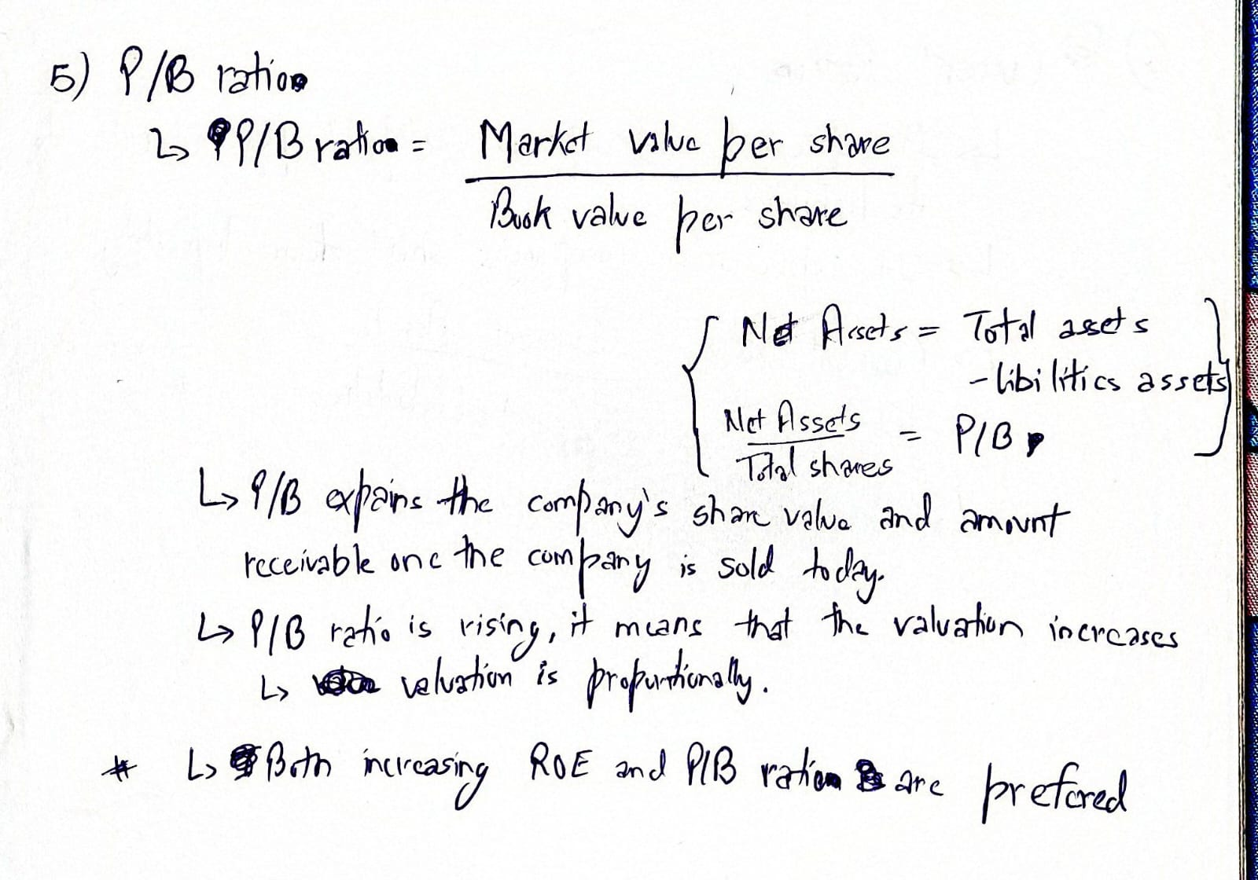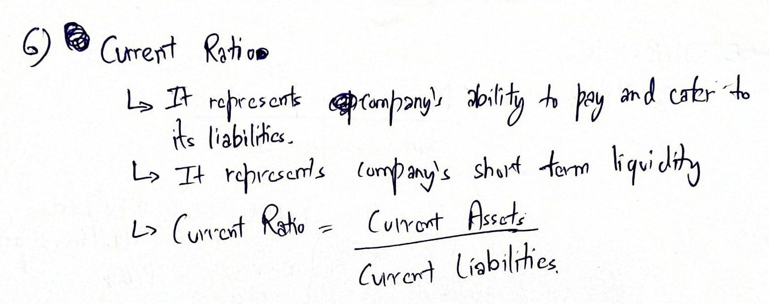

Other Topics:

Balance Sheet:

<https://www.investopedia.com/terms/b/balancesheet.asp#toc-what-is-a-balance-sheet>

Capital Expenditure: <https://www.quora.com/Where-is-capital-expenditure-on-a-balance-sheet>

<https://www.investopedia.com/terms/c/capitalexpenditure.asp>

Formula Sheet (in Google Sheets)

<https://docs.google.com/spreadsheets/d/1hNTU9_ymtMQXcIVEDFHkLgpYSEz2ZDpp6rCIdPEjriw/edit#gid=1912259510>